Week in Review - Week 11, January 11-17
Alex Shvartsman

GRAND PRIX: AMSTERDAM
This Grand Prix gathered over 640 competitors, including several top pros who are not often seen around the Grand Prix scene, such as Gary Wise, Casey McCarrel, Olle Rade, and Jon Finkel himself. A record number of American players made the journey across the pond this time, and it was felt in the top 8, with US players taking four of the slots.
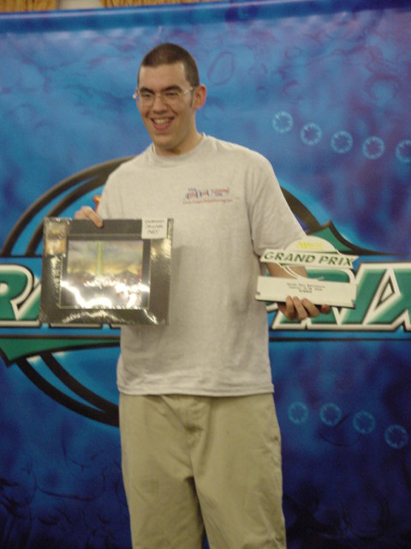
Chris Benafel has finally broken has "Finalist Curse." Having come in second in PT LA, US Nationals, and GP Dallas, Benafel faced Xavier Curto Vives from Spain in yet another final match. This time around, Benafel finally claimed the top prize. His aggressive B/R deck with two Void did not fail, and the final match was over in about fifteen minutes.
In addition to the standard $2400 prize, Benafel also won original artwork for Sulfur Vent, graciously donated by Ed Beard, Jr. who was signing cards at the event during the weekend.
Sideboard's complete coverage of GP Amsterdam can be found here. There is also independent coverage by Kim Eikefet, available here.

COMING UP: EVENT HORIZONS INVITATIONAL
Top 16 players from Texas and Louisiana (including the names you might recognize such as Lan Ho, David Williams, Adrian Sayers, and Bryan Hubble) will compete in a variety of wacky formats. Sideboard will be covering this event in detail (yours truly is off to Houston on Friday). Expect deck lists, photos, match coverage and more on The Sideboard sometime on Monday or Tuesday. Until then, you can learn more about this event by visiting the Event Horizons web site.


NEW FACES AT WOTC
Renowned rules guru Paul Barclay has been hired to fill the position of DCI Rules Manager. That means Barclay will now be the final authority on complicated card interactions and other various rules. Barclay has been an online rep for many years, and an active tournament judge. He head-judged Grand Prix: Manchester a few months ago.
Most recently, Barclay has been widely praised for designing a very original "Full English Breakfast" Extended U/G Survival deck variant, using such unorthodox cards as Volrath's Shapeshifter and Phyrexian Dreadnought.
Barclay will be moving from the United Kingdom to WOTC HQ at Renton, WA shortly.

UPCOMING MASTERS SERIES EVENTS
Many players have been inquiring about the status of the remaining two Masters Series events this season. I've talked to Randy Buehler, and have been authorized to share the following information with you folks:
Los Angeles will not host a Masters Series tournament. Instead, they will be held in Tokyo and Barcelona. Tokyo Masters will feature a Team Trios format. In order to qualify for the Gateway tournament, teams will have to have an established DCI rating (exact rating level to be announced), so no "Mercenary," fly-by-night teams will be able to participate.
Barcelona Masters tournament will feature Invasion Block Constructed format, same as Pro Tour: Tokyo. It will be interesting to see whether pro players are able to "break" the metagame established at PT Tokyo.
Stay tuned to The Sideboard for the more detailed (and more official) announcements, coming shortly.

MAGIC TRIVIA
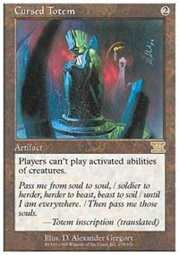
Last week's question was to name an artifact that can never be destroyed by Gorilla Shaman. The answer I had in mind is Cursed Totem. With Totem in play, Gorilla Shaman cannot destroy much of anything, least of all the Totem itself. However, a number of other answers work too. Any non-creature artifact that can become a creature in response to Shaman's ability being activated would work. That means correct answers include Chimeric Idol, Jade Statue, Chimeric Staff, etc.
This week's question is a bit harder. Your goal is to build a 60 card deck using only a copy of a single card, yet have the deck be able to deal 20 damage to your opponent. A deck of 60 Lightning Bolts for example would not work, because you need Mountains to cast them. A deck of 60 Mishra's Factories would work fine. Now the question is, how many different decks like this can you build? I can currently think of at least 13, but there may be more.
This question is courtesy of Sol Malka. Answer will be posted in next week's column.

BEST OF THE NET
While a number of web sites offer high-level strategy content, Star City has also nurtured their casual audience. A great way to begin following their columns is by reading the Casual Rules Primer by Jon Chabot. It discusses a variety of subjects pertaining to multiplayer gaming. Anyone who is more into casual than tournament play, is well advised to check it out.

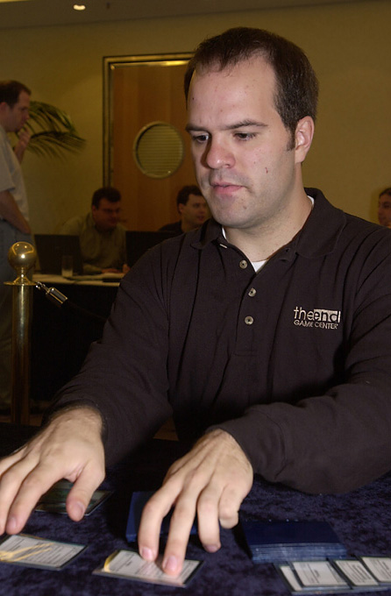
PLAY OF THE WEEK
I quote Derek Rank, who was kind enough to e-mail me with this incredible play:
"This play happened a long time ago, but it is so good that it needs repeating. The format was 5th/Visions Rochester draft. The matchup was Mike Long vs. Jon Finkel. It was getting pretty late in the game and both players had gone through a good chunk of their decks and had a ton of land in play. Finkel was at 5 life, but the creature battle was really beginning to swing his way.
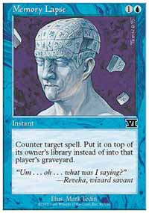
Mike knew he was in trouble. During his draw phase, he drew Kaverk's Spite. The 5 life would be enough to kill Finkel, but Mike knew from the draft that Finkel had a Memory Lapse and believed that Finkel was holding it because of way he had been playing and because of the small number of cards left in each player's libraries. Of course, if Mike casts the Spite and sacrifices everything only to have Finkel Lapse his spell, then he's dead. Mike thought about it for a while, decided he could survive one more attack, and said "go."
Finkel attacked on his turn, and Mike sacrificed a number of creatures to chump blocks and survived the turn. Finkel says "go" and - sure enough - he had plenty of mana for the Memory Lapse. Mike Long entered his draw phase. He then tapped SIX black mana into his pool. He put the drawing of his card onto the stack. He then cast the Spite in response and sacrificed all his permanents and discarded his hand. Now, even if Finkel Lapsed the Spite, Long would immediately draw it and have the mana to cast it, even though he sacrificed everything. Realizing what a magnificent play Long just made, Finkel just shook his head and tossed the Memory Lapse on the table. Whatever your opinion of Mike Long is, you have to admit that he does have some unbelievable play skills. If that wasn't the greatest play of all time, it certainly is in the top 5."

BAD PLAY OF THE WEEK
Unfortunately for me, this week's bad play of the week was made by yours truly.
I was playing against Brian Davis in the ninth round of Grand Prix: Amsterdam. I drafted a solid U/B deck, while he was playing W/U/b.
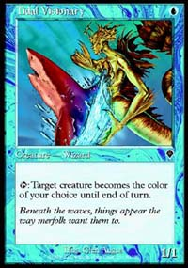
I was down a game, but things were looking good in game two. I had Tidal Visionary and Ravenous Rat on the ground. They were cheering on a Zanam Djinn, which was serving for 3 points of damage in the air. Brian Davis had no cards in hand, a Dream Thrush and a 4/4 Benalish Lancer in play.
He was then at 7 life. I wanted to kill him in 3 turns rather than 4 (he could chump-block with Dream Thrush for a turn) since there may have been a number of cards in his deck that could swing the situation his way. I used Tidal Visionary to turn his Dream Thrush white, cast Wash Out, and attacked with my other two creatures to reduce his life total to three.
Brian drew Reviving Vapors, then found Shackles for my Djinn, replayed his guys and eventually came back to win the game, and the match.
Of course, the correct play would have been to turn my Ravenous Rats white, so that I could recast it and make him discard the Benalish Lancer instead. I got greedy and sacrificed card advantage in favor of time advantage a bit too freely. Brian Davis went on to finish in the 3rd place, while I had to be content with a 23rd place finish.
Got a play of the week, or another interesting anecdote for this column? E-mail me at ashv@concentric.net.

